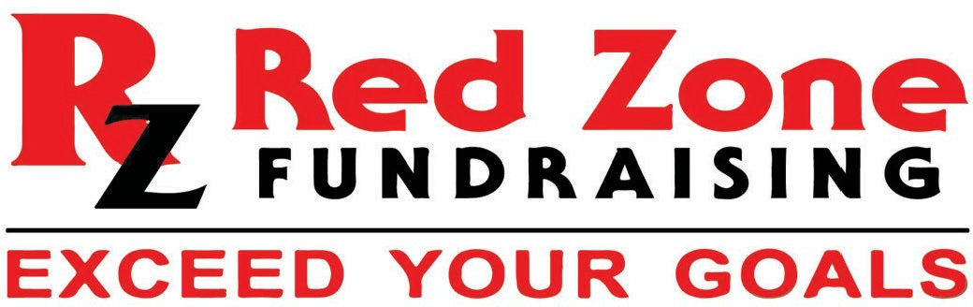

Parent/Guardian,
We will be launching our Red Zone Fundraising efforts in the coming weeks and wanted to answer any questions you may have to gain participation. Without your participation, this fundraiser will not work. With parent/guardian participation, this will be a tremendous success and without it, we will not reach our goals. Red Zone Fundraising online campaign has simplified the way teams and organizations raise money. Fundraising is vital for the success of our program and Red Zone Fundraising allows us to spend more time practicing, rather than fundraising, which will translate to the success of our program.

All that we ask is that each parent/guardian help their student gather 20/25 quality email addresses of their biggest supporters, i.e., grandma, grandpa, aunts, uncles, and family friends. Then, invitations will be sent to these people where they can view the groups' fundraiser page and decide if they would like to support or share on social media. Red Zone Fundraising has worked with thousands of teams and the best fundraisers are because the parents have helped in gathering emails. We are confident that there are many people eager to support your young student and Red Zone Fundraising's platform affords them the opportunity to help if they choose. Once complete please sign the bottom of this page and have your son or daughter return to me.

- Your contacts are strictly PRIVATE, PROTECTED, and will never be REDISTRIBUTED.
  - SAFE and PROTECTED - WeFund4u is the safest online donation platform available. All information is private,100% secure, and will never be redistributed.
  - ONLINE PLATFORM - We will reach potential donors through email, text, and all social media. Through these mediums, donors can visit the teams’ fundraiser page and choose to help support the cause with a donation.

HOMEWORK *VERY IMPORTANT*

Example Donors | Email Addresses | Example Donors | Email Addresses
Mom |  | Mom Best Friend
Dad |  | Mom Best Friend
Grandma |  | Dad Best Friend
Grandpa |  | Dad Best Friend
Aunt |  | Family Friend #1
Aunt |  | Family Friend #2
Aunt |  | Family Friend #3
Aunt |  | Family Friend #4
Uncle |  | Family Friend #5
Uncle |  | Family Friend #6
Uncle |  | Neighbor
Uncle |  | Neighbor
Cousin |  | Neighbor
Cousin |  | Neighbor
Cousin |  | Mom Co-worker
Cousin |  | Mom Co-worker
Godparent |  | Mom Co-worker
Godparent |  | Dad Co-worker
Godparent |  | Dad Co-worker
Godparent |  | Dad Co-worker
Thank you so much for your support!
QUESTIONS?
If you have any questions, please don't hesitate to contact me, or email our fundraising coach Sean at
ssantos@redzonefund.com

PARENT SIGNATURE: X

